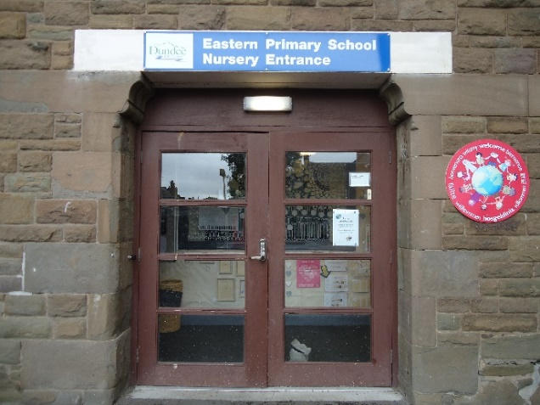

NURSERY DAY
Morning session times – 8.30 – 11.40am
The nursery door opens at 11.30am for morning session collection.
Afternoon session times – 12.15 – 3.25pm
The door opens at 3.05pm for the afternoon session collection.
If you require access earlier than those times, then please ring the doorbell and a member of staff will help you.
We understand the importance of flexibility for parents hence the drop off and collection time periods. It is important that your child is in nursery by the end of the drop off times, so we can settle them into their day. This allows all children the opportunity to start their day positively.
NURSERY STAFF
Senior Early Years Practitioner – Miss Leeann Mckelvie
Nursery Teacher – Mrs Jennifer Paterson
Early Years Educators – Mrs Dawn Taylor, Mrs Rebecca Lennox, Miss Rachel McGarrity and Mrs Leanne Broughall.
Early Years Support Assistants – Mrs Vicky Laing and Mrs Sarah Alexander. Modern Apprentice – Miss Rachel Yule.

KEYWORKER GROUPS
Each child will be assigned a member of staff who will be their keyworker. The nursery groups and keyworkers are;
Sunbeams – Mrs Paterson (Mon/Tues) & Mrs Taylor (Wed-Fri)
Rainbows – Miss McGarrity
Shooting Stars – Mrs Lennox & Miss Mckelvie (Wed)
Planets – Mrs Broughall
SETTLING IN
When your child begins their first session with us, we will explain the process of settling in with you as parents and jointly decide on the best way to help your child settle into the nursery. We expect that you as the parent, carer or close relative, will stay for most of the settling in sessions, gradually decreasing your time at the setting until your child is comfortable and well settled with us.
SIGN IN/OUT SHEET
Please use the sign in/out sheet when dropping off and collecting your child from nursery. This is located at the nursery entrance.
NURSERY LUNCHES
Lunch is served between 1130 and 1215 in the nursery building. Children are welcome to bring a healthy packed lunch or order a nursery school lunch. The cost is currently £2.15 per meal. Payments are made through the ‘Parent Pay’ website. Cash can still be used for lunch payments either on the Monday of each week, or on the day a meal is required. There is a daily choice of three main meals – please co-ordinate your child’s name label at the nursery entrance with the colour of meal they would like to order.

HEALTH PROMOTING SCHOOL
Eastern Primary School and Nursery are both ‘Health Promoting Schools.’ Therefore sweets, ‘energy’ and fizzy drinks are discouraged. To safeguard children with allergies, we ask that birthday cakes and other confectionary are not handed in for distribution by nursery staff. Likewise, we would ask that nuts are not provided in your child’s lunch box.
SNACK
We ask for a snack donation of £2 per week. This can be paid on a termly basis as detailed below. Please use ‘Parent Pay’ or cash to your child’s keyworker.
Term 1 – Aug – Oct - £16
Tern 2 – Oct – Dec - £18
Term 3 – Jan – March - £24
Term 4 – April – June - £22
There is a snack menu displayed at the nursery entrance – please let us know of any allergies.
MEDICATION
Parents wishing nursery staff to administer medication to their child throughout the nursery session must discuss this with the Senior EYP, Miss Mckelvie. Nursery staff can only administer medication that has been prescribed by a doctor or chemist and has a label with your child’s name and dosage required. All medications required by nursery children should be given to their keyworker or SEYP who will store these in a locked cabinet.
DROP–OFFS AND PICK UPS
The area around the school and nursery is prone to traffic congestion at the start and end of days. If using a car to deliver/collect children, please park away from the school and nursery area and walk a short way between the nursery and the car.

BUGGIES
We kindly ask for any buggies to be left in the vestibule area to avoid congestion in the nursery.
CHILD PROTECTION
Mr Gordon Ferrier, Mrs Michelle Radcliffe and Mr Ben Clark are the designated child protection officers within the school. You can contact them should you have concerns about the safety or wellbeing of any child.
SPARE & SOILED CLOTHING
Each child is allocated a coat peg which has a small bag for you to leave some spare clothes in case of any accidents. If your child needs changed for any reason, there will be a label on their peg to notify the person who is collecting them. The soiled clothing can be collected from the box situated in the toilet within the art studio.
ART WORK
Each group has a labelled artwork box, please help your child to find their artwork at the end of their session.
WELLIES
We encourage children to bring a pair of wellies into nurseries for wetter outdoor learning days, please label with your child’s name and store these on our wellie rack.
TOYS FROM HOME
We would encourage all personal toys to be left at home. Children can become upset if these get lost or broken.
STAR MOMENTS WALL
We encourage children and families to share their achievements at home and in the wider community with us. We have a special ‘Star Moments’ wall where these can be displayed. Please ask staff for a ‘Star Moments’ sheet anytime.
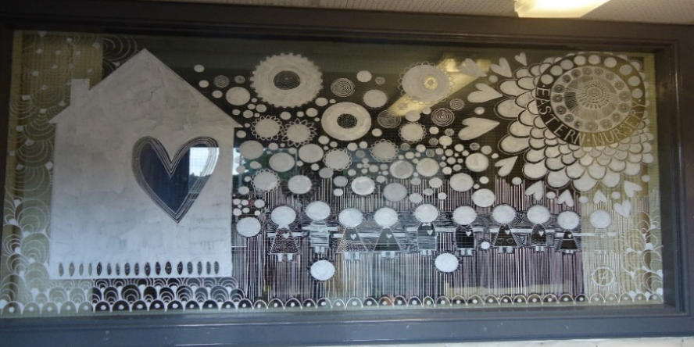
LEARNING JOURNALS
Each child will be given a journal at the start of their nursery journey. We ask parents to bring us some photos from home for the beginning of their learning journal to help us get to know the child and their family better. The learning journal will be developed over the year, documenting your child’s significant learning and meaningful nursery experiences.
RESPONSIBLE CITIZENS
To encourage the children’s independence at nursery, we suggest velcro or slip on shoes so children can develop important self-help skills.
It is helpful for all belongings to be labelled with your child’s name too.

SELF-REGISTRATION & TOOTHBRUSHING
We kindly ask parents to assist their child to self – register beside their keyworker at the start of their session. There will also be an opportunity to brush their teeth here before going off to play. Please ensure you greet your child’s keyworker to let them know they are in nursery.

PROMOTING CURIOSITY & IMAGINATIONS THROUGH PLAY
We are always on the hunt for resources to develop our loose parts play. You will find many of these around the house or in your local community. Items such as pebbles, shells, sticks, logs, thread reels, ribbon, feathers, leaves, baskets, plant pots, keys, pasta & pulses.
We would be most grateful for donations of these items!
Please see our ’Loose Parts Play’ poster at the front door for more ideas!

SCHOOL & NURSERY APP

Eastern Nursery team offer some extra communication via the ‘school app.’ This can be downloaded from your app store free of charge.
Username – **** Password – ****
If you have any questions or queries, please talk to the nursery team.
Many Thanks.

COMMUNITY TRIPS
Trips are arranged in response to the children’s learning and interests. Please ensure your trip consent form is returned. Staff will make you aware of any planned trips as they happen.
We are always looking for parent helpers to support the children on any outings. Let us know if you would like to help.

